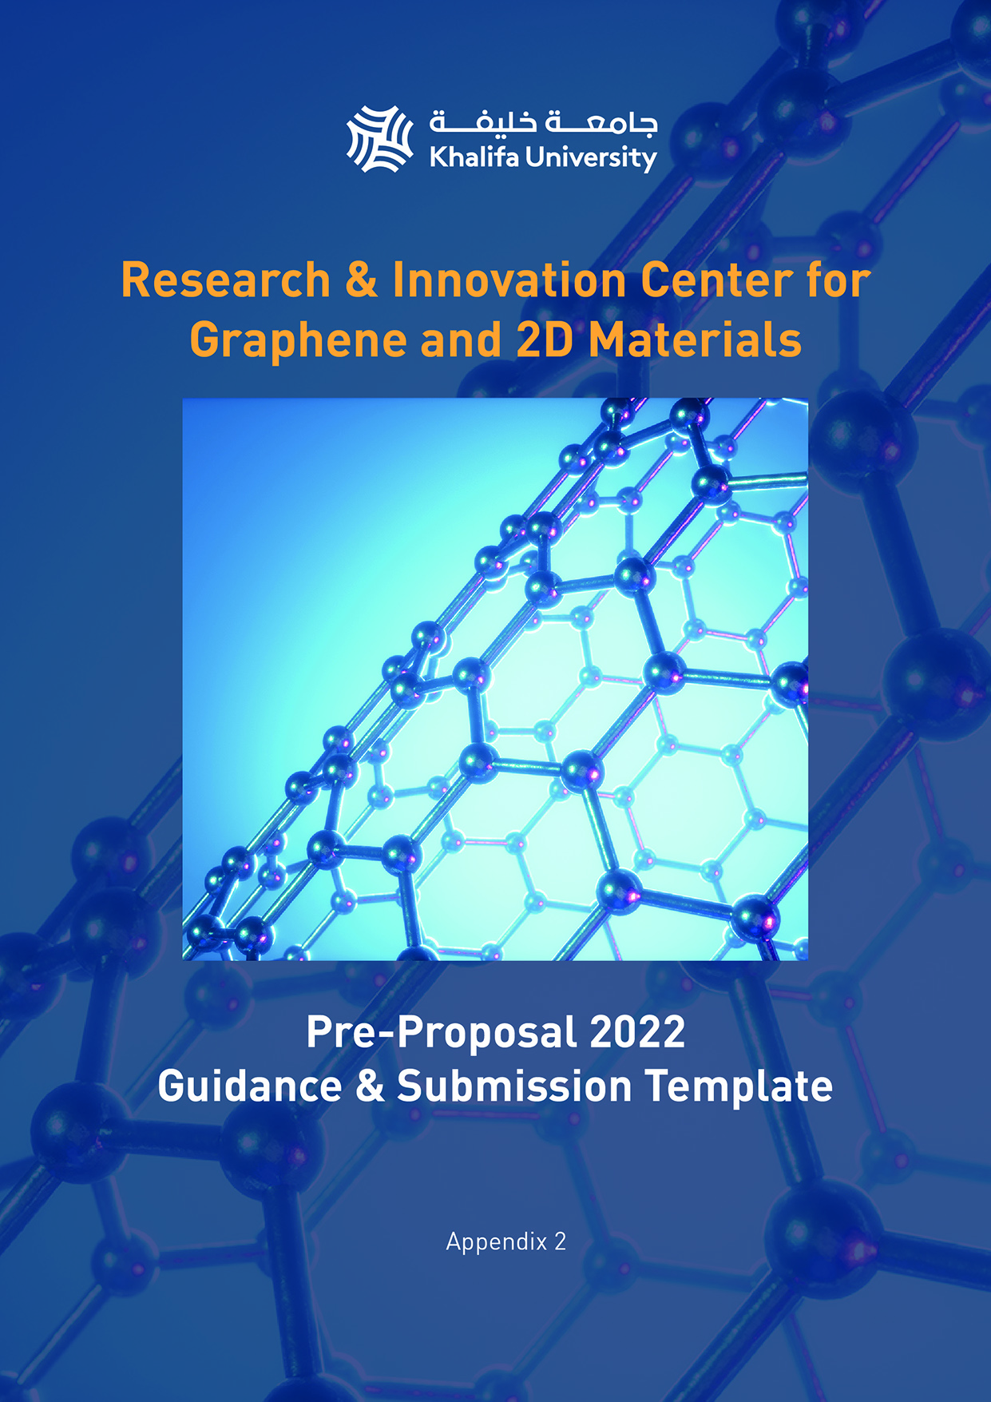

PRE-PROPOSAL SUBMISSION GUIDANCE

Deadline for Submission of Pre-Proposals
Wednesday, 20 July 2022 - 1pm GMT

Submission via web portal: www.ku.ac.ae/ric-2d

IMPORTANT

Applications are to be submitted online.

The submission portal can be accessed via the link above, it will go live in mid-June. Following the activation of the portal, it will be possible to create an account in order to save and edit the application prior to the submission deadline.

The Pre-Proposal submission must include the completion of the online Cover Form and a completed Pre-Proposal Template (Appendix 2). Appendix 2 is to be uploaded as a single .pdf file within the online form.

The .pdf file name should follow this structure:

Organization name – lead applicant surname – first name. pdf
E.g. khalifa-jones-john.pdf

The project description must adhere to the sub-headings in the pre-proposal template as these are aligned to the evaluation criteria. All other guidance information included in the template document can be deleted.

Page limits, formatting specifications etc. must be followed for the pre-proposal to be valid for consideration. Any supplemental information that exceeds the specified requirements will be deleted. See the Call for Proposals document for full details.

Queries regarding the call and submission process can be sent by email to RIC-2D.info@ku.ac.ae

Pre-Proposal Template – Part A: Project Overview
(maximum 3 pages)

Research / Technical Challenge (select as appropriate)
What is the problem to be addressed? What is the market need driving this project and how does the project stand to address this? Specify whether the activity seeks to address a technical boundary, new problem or an existing need in a novel way? Specify the key research / commercial goal(s) to be achieved through this project.

Innovation
Clarify what is distinctive about the proposed activity, summarizing the potential for scientific advancement / technology adoption. Identify how this has the potential to impact the relevant Priority Area(s) listed in this call. State what the current source of competition is in this area and how the proposed concept stands to advance on the competition.

Deliverables
Outline the key tasks and deliverables, detailing the how this stands to impact the TRL advancement in this area. Specify what key facilities and/or equipment are available to accomplish the proposed effort in addition to highlighting any new CAPEX investment that would be necessary to complete the tasks.

Risk
Specify the primary risk areas linked to the deliverables. Justify why this approach is necessary, what stands to be gained and what can be done to minimize major risks.

Project Team & Partner Organizations
Provide an overview of the team involved in the project, justifying how they are instrumental to the project deliverables and why this constitutes the most appropriate team for the success of the project. Provide additional context to any project partners located in the United Arab Emirates, confirming whether this represents a new or ongoing collaboration.

Capacity Building
Identify the anticipated gain this project will generate in terms of targeted applications and/or markets, the envisioned breakthrough or potential major impact for Abu Dhabi and global markets arising from this project. This can include but is not limited to knowledge, economic and/or environmental advances. Identify the key regional collaborations and stakeholders most likely to benefit from developments in this field, identifying any active affiliations.

Disclosure
Disclose existing background intellectual property upon which the proposed work is based (if any). Disclose prior or current investors with claims on the commercial outcomes of proposed activity (if relevant). Identify the added value this Fund stands to provide compared to other sources of available investment/funding.

Pre-Proposal Template – Part B: Supporting Material
(maximum 2 pages)

Include citations, images, graphics, tables etc. referenced in Part A. URL’s should not be included. Only legible content can be evaluated.

Pre-Proposal Template – Part C: Curriculum Vitae
(maximum 2 pages per person)
RIC-2D Project Title
Full Name | Rank / Professional Title | Institutional Affiliation
Personal Statement (summarize how technical/professional background is relevant to the proposed activity)

Education (highest level achieved)

Career History (positions and additional management responsibilities)

Research / Technology Development Track Record (sponsored research, patents, technology transfer activity etc.)

Publications (for faculty submissions) Include: ORCID ID / h-index + 5 most relevant to the proposed Project.

